# **CS559 – Computer Vision**

## Assignment No. 2

## [1]*

1. Explain conditions under which the use of a lookup table (LUT), instead of calculating the mapping pixel by pixel, reduces the computation. Express the conditions in terms of number of graylevels L and resolution n.
2. Many (infinite number) of passes of contrast stretching with the mapping $g=\left\{\begin{aligned}0.4f for 0≤f≤119 \\ f for 120≤f≤255\end{aligned}\right.$

is applied to a perfectly equalized 8-bit input image. Draw and carefully label the normalized histogram

of the output image.

1. An 8-bit image has a normalized histogram defined by $h(l)=\left\{\begin{aligned}\frac{1}{206} for 0≤l<100 and 200≤l<256 \\ \frac{1}{412} for 100≤l<200\end{aligned}.\right.$

Suppose that each pixel is ANDed with 0100 0000, and is set to white if the result of ANDing is non-zero, otherwise is set to black if the result is zero (this operation is called bit-plane slicing). Draw and carefully label the normalized histogram of the resulting output image.

4. The purpose of this assignment is for you to come up with a measure (formula, procedure, or algorithm) to determine the similarity between two color images, with 0 being completely difference and 100 being exactly the same. Explain why your measure is appropriate. Program your procedure and apply it to determine how similar each image B, C or D is similar to the image A. One method would be to compare the histogram of the images, but you can propose an alternative method of your own. I do not expect you to proposed a sophisticated measure, rather I want you to appreciate that images that are so easy for our eyes to identify their similarity and differences, are very difficult to do the same using computer vision. Note: Download this assignment, then open it, click on each image and save it as .jpg.

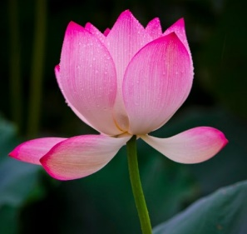 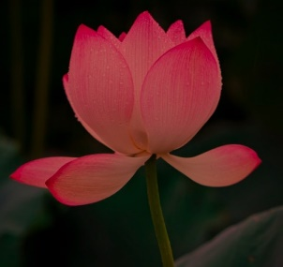 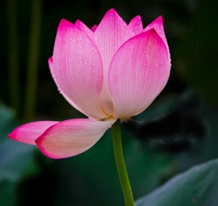 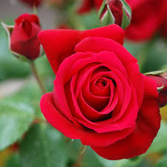

A B C D

**5.**  Write a program in Python or Matlab that takes an RGB image of size W by H and an integer k and produces an output image of size kW by kH where k is an integer greater than one (sometime this is called *resampling*). The enlarged image must be in appearance as close as possible to the original image. Use bilinear interpolation or another technique of your choice. Demonstrate your work by producing an input image and two output images one with k=2 and one with k=3.

1. * Please type your solutions to Problems 1-5 using a word processor such as Word or Latex. For Programs, submit a short report in Word or Latex. In this report briefly explain the features of your program, any findings and conclusions. Provide outputs (images) to support your report. Each image must have a detailed caption explaining what processing has been done, etc.